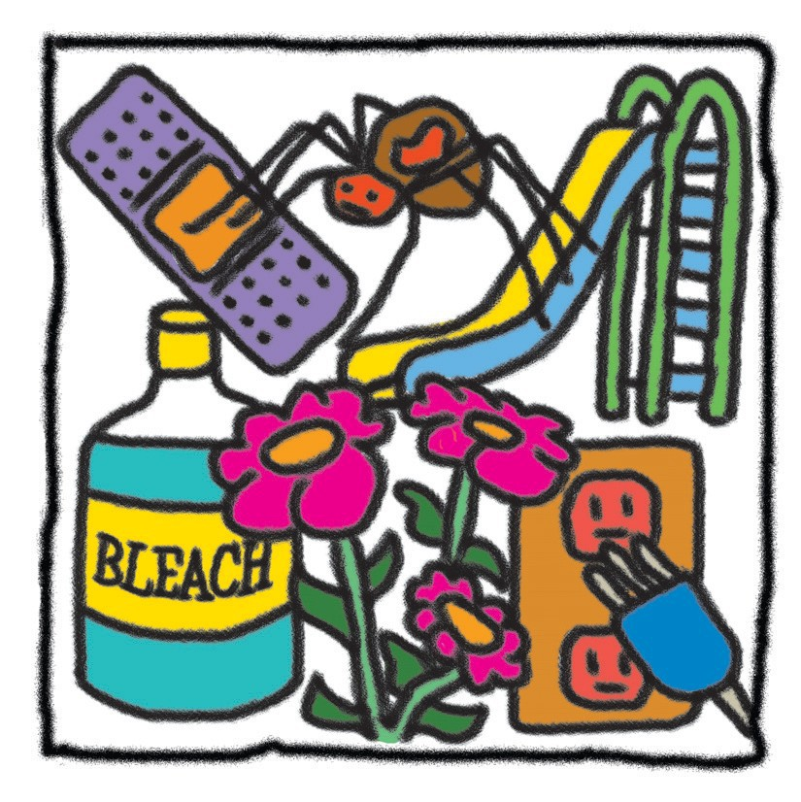

Safety Precautions
Training Review Module 3 Clock Hours

Instructions For Completing
This Training Module
- After reviewing this material with your day home rep-­‐‑ resentative, please read and study the materialcarefully.
- Complete the test for the material and return it to Child Food Program Of Texasatyourconvenience. There is no deadline to have this test back to us.
- When we receive your completed test, we will evalu-­‐‑ ate it and then send you a certificate for 3 clock hours for completing this material.

Objectives
- To provide information regarding safety precautions and emergency precautions.
- Toprovideinformationonmeasurestopreventacci-­‐‑ dents and injuries.
- To provide information on how to deal with and plan for accidents, injuries andemergencies.

Table of Contents
- Arrivals and Departures
Starting Each Day . . . . . . . . . . . . . . . . . . . . . . . . . Pg 3
Ending Each Day . . . . . . . . . . . . . . . . . . . . . . . . . . Pg 3
- Falls, Bumps, and Cuts
Babies . . . . . . . . . . . . . . . . . . . . . . . . . . . . . . . . . . . Pg 4
Toddlers . . . . . . . . . . . . . . . . . . . . . . . . . . . . . . . . . Pg 4
Older Children . . . . . . . . . . . . . . . . . . . . . . . . . . . Pg 4
Indoor Accident Prevention . . . . . . . . . . . . . . . . Pg 4 Safety Rules . . . . . . . . . . . . . . . . . . . . . . . . . . . . . . Pg 4
Hazardous Conditions . . . . . . . . . . . . . . . . . . . . Pg 5
Safety Evaluation . . . . . . . . . . . . . . . . . . . . . . . . . Pg 5 Outdoor Accident Prevention . . . . . . . . . . . . . . . Pg 6
- Suffocation and Strangulation Bedding . . . . . . . . . . . . . . . . . . . . . . . . . . . . . . . . . . Pg 7 Household Objects . . . . . . . . . . . . . . . . . . . . . . . . Pg 7 Toys . . . . . . . . . . . . . . . . . . . . . . . . . . . . . . . . . . . . . Pg 7 Foods . . . . . . . . . . . . . . . . . . . . . . . . . . . . . . . . . . . . Pg 7 Furnishings . . . . . . . . . . . . . . . . . . . . . . . . . . . . . . . Pg 7
- Animal Bites
Safety Guides . . . . . . . . . . . . . . . . . . . . . . . . . . . . Pg 8
Animal Bites . . . . . . . . . . . . . . . . . . . . . . . . . . . . . Pg 8
- Insect and Snake Bites
Insects . . . . . . . . . . . . . . . . . . . . . . . . . . . . . . . . . . Pg 9
Snakes . . . . . . . . . . . . . . . . . . . . . . . . . . . . . . . . . . Pg 9
- Poisoning
Household Chemical Products . . . . . . . . . . . . . Pg 10 Drugs . . . . . . . . . . . . . . . . . . . . . . . . . . . . . . . . . . . Pg 10
Cosmetics, Lotions, and Other External Preparations . . . . . . . . . . . . . . . . . . . Pg 10
Pesticides . . . . . . . . . . . . . . . . . . . . . . . . . . . . . . . . Pg 11
Petroleum Products . . . . . . . . . . . . . . . . . . . . . . . Pg 11
Fume Poisoning . . . . . . . . . . . . . . . . . . . . . . . . . . Pg 11
Plant Poisoning . . . . . . . . . . . . . . . . . . . . . . . . . . . Pg 11
Food Poisoning . . . . . . . . . . . . . . . . . . . . . . . . . . . Pg 13
Lead Poisoning . . . . . . . . . . . . . . . . . . . . . . . . . . . Pg 13
Poison Prevention . . . . . . . . . . . . . . . . . . . . . . . . Pg 14
- Water Safety
Wading Pools . . . . . . . . . . . . . . . . . . . . . . . . . . . . Pg 15
Swimming Pools . . . . . . . . . . . . . . . . . . . . . . . . . . Pg 15
Swimming Lessons . . . . . . . . . . . . . . . . . . . . . . . Pg 15
- Automobile Injury Prevention
Rules . . . . . . . . . . . . . . . . . . . . . . . . . . . . . . . . . . . . Pg 16
Safety Precautions . . . . . . . . . . . . . . . . . . . . . . . . Pg 16
- Fires, Burns, and Electric Shock Preventing Fires and Burns . . . . . . . . . . . . . . . . Pg 17 Preventing Electric Shock . . . . . . . . . . . . . . . . . . Pg 17
- Planning for Emergencies
Fire . . . . . . . . . . . . . . . . . . . . . . . . . . . . . . . . . . . . . Pg 18
Severe Weather Conditions . . . . . . . . . . . . . . . . Pg 18 First Aid . . . . . . . . . . . . . . . . . . . . . . . . . . . . . . . . . Pg 18

Arrivals and Departures

Starting Each Day
You are responsible for the children in your care from the time they arrive until the time they leave. Because of this, insist that children be delivered to your door, not just dropped off at the gate or sidewalk, unless an adult is thereto greetthem. Parentsshould beresponsible for seeingthattheirchildrenaresafelyinyourcarebefore leaving them.

Ending Each Day
Youalsoshouldhaveparentstellyouwhowillpickup theirchildintheafternoon. Donotallowanyoneother than an authorized person to take any child in your care. You or another adult with the center should see that a child leaves your care with the right person.

Falls, Bumps, and Cuts

Whenever you care for young children, minor falls, bumps, and cuts are bound to happen. But there are many things you can do to help prevent serious accidents and lower the number of minor accidents.

Babies

Infants need total protection. The safest places to leave an infant alone are in a crib with the side up or in a playpen. Leaving an infant on a couch or bed, even for a minute, is extremely dangerous. It may result in a serious fall.
Pick up an infant whenever you must reach for anything that keeps you from having at least one hand on the baby. Turningyourback, evenforasecond, canberisky.

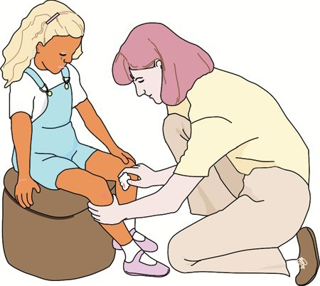

Toddlers
Toddlers also need extra protection. They are learning to use their new ability to move around and spend most of their time exploring. Their curiosity helps them learn, but it can also be dangerous.
Toddlers are not steady on their feet and they will grab at things to keep from falling. They also fall or trip over things on the floor that an older child will walk around.

Older Children
Older children need less protection, but they, too, can get in dangerous places. They often try to climb ladders, stairs, furniture, boxes, and toys, and they can be injured. Preschool children also open boxes and other containers which have dangerous contents.

Indoor Accident Prevention
Youcanhelppreventindooraccidentsbyfindingand correcting hazardous situations, teaching children safety rules, and remembering that you are a safety model.
Children will imitate your habits. If you stand on an un-­‐‑ steady surface, such as a wagon, to reach for something, so willthe children.

Safety Rules

Tell children about common dangers. Use words that are simple enough for each child to understand and repeat safety rules often to help children remember. Some ex-­‐‑ amples are:
w Handle tools such as scissors and screwdrivers with care. Carry tools with the handle in the palm of the hand and the sharpest end pointed down.
w Do not put sharp objects, small objects, rocks, sticks, toys, and other such items in the mouth. They can be dangerous if swallowed. Also, objects inthemouthcanpokeaholeinachild’scheekor lip if the child falls down. Do not put dirty fingers in the mouth.
w Donotplaywithortouchwallplugsandelectric cords.
w Never play with or touchmatches

Hazardous Conditions
w Bookshelves, cabinets, and otherfurniture—Use nailsorscrewstoanchorfurniturewhichcanbe pulled over by a child. Furniture with sharp edges shouldberemovedfrom theroom, orthesharp edges should be covered.
w Floors—Keep floors and doorways free of objects which can cause children to trip and fall. Highly waxedfloorsmaybeslippery.
w Bathrooms—Never leave young children in the bathroom alone. Slipping, drowning, or scalding may occur.
w Spilled liquids—Clean up spilled liquids immedi-­‐‑ ately. If necessary, throw newspaper over the liq-­‐‑ uid until it is soaked up. Check bathrooms for wa-­‐‑ ter spills that could cause children to slip and fall.
w Broken Equipment—Do not use any broken equip-­‐‑ ment until it is repaired.
w Cleansing agents and other housekeeping sup-­‐‑ plies—Keep these where children cannotreach them.
w Spraycansalwaysshouldbeoutofthereach of children.
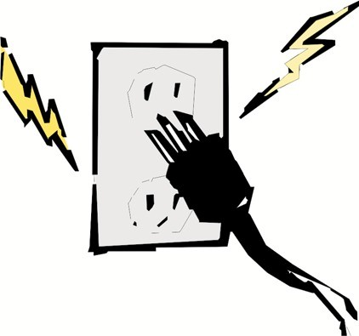w Electrical outlets—Keep outlets covered at all times.
w Doors, passageways, and handrails—Keep doors and halls free of objects, and teach children to use handrails when using stairs. Be sure handrails are secure.
w Loose boards and protruding nails—Make carpen-­‐‑ try repairs immediately.
w Heaters, fans, and fireplaces—Screen allheaters, fans, and fireplaces. The moving blades of a fan are fascinatingtochildren, butchildrencanlosefin-­‐‑ gers trying to touch the blades. Keep screened fans out of the reach of children.
w Lighting—All play areas and halls should be clearly lighted.
w Splintered wood—Sand or rasp all splintered sur-­‐‑ faces.
w Matches—Keep matches in a place inaccessible to children.
w Large bathroom fixtures—Keep a step stool or a box in the bathroom for children to stand on. Be sure the stool or box is sturdy and won’t tip over.

Safety Evaluation
Check each day before the children arrive to be sure there are no sharp objects such as scissors or broken toys whichmightharm achild. Regularlycheckthesafety features of your home or center. Is any wood splintered? Are stair rails sturdy? Are the fireplace and fan screens still tightly fastened?

Outdoor Accident Prevention
Correctingandavoidinghazardousconditionsinyour yard or play area are critical to accident prevention. In addition, children need to be taught safety rules, and they should always be supervised.

Ground Area
w Everyday, checkyouryardorplayareaforobjects which may cause a child to trip and fall.
w Fillinorsmoothoutholes, bumps, orotherdan-­‐‑ gerous areas.
w Fenceoffanareathatisdangerousifitcannot be fixed.
w Sweepanysandfrompavedareastoavoid slipping.
w Never leave garden tools lying around.
w Remove any poisonousplants.
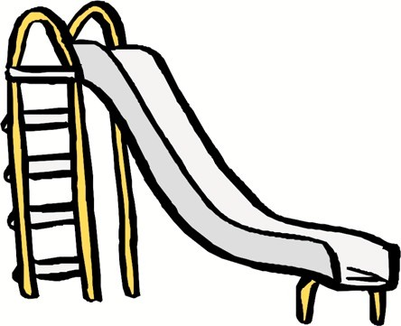w Supervise the children closely anytime there are puddlesontheground.
w Keepfencingingoodrepair. Provideatemporary substitute barrier, if a gate is broken, and repair the gate immediately.
w Check for broken glass. When yards are near streets or highways, bottles and cans sometimes arethrownontheplayground.

Equipment
When choosing outdoor equipment and toys, consider theageofthechildren. Forexample, childrenunder 2 years of age may not be able to pedal or use a tricycle safely. They may get their legs caught and fall. Four-­‐‑ wheeled toys which children can push with their feet are much safer and more usable.
w Anchor playground equipment with concreteor stakessoitcannotbemoved. Besuretheequip-­‐‑ ment is in good repair and replace worn-­‐‑out parts immediately.
w Supervise closely any activity using ropes.
w Teach children safety rules and the right way to useplayground equipment. Children often are injured by jumping out of a swing or running in front of someone who is swinging. Safety rules will depend on the types of equipment you have in yourplayyard.
w Supervise the areas where children are playing on climbing equipment. Stay closer to the jungle gym or climbing dome than the sandpile, which is less dangerous.

Suffocation and Strangulation

It takes only a minute or two for a child to strangle or suffocate. Preventionisabsolutelycritical. Manytimes, adultsoverlookthingswhichcanbedangerousfora small child.
Bedding
Cribsandplaypenscanbesourcesofdangeriftheslats arelooseorspacedmorethan 21/2 inchesapart. Alarge space between slats can allow the baby’s head to get caught. Repairlooseslatsand useabumperguard on cribsandplaypensthathavetoomuchspacebetween slats. Do not allow infants to sleep with a pillow.
Never cover a crib mattress or cot with thin plastic or laundry bags. Many children have suffocatedbecause of plasticbags. Useacommercialmattresscover.

Household Objects

Keep all play areas free of objects which can get caught in the child’s throat. Some things can cut off a child’s air supply or, ifswallowed, can puncture a vitalorgan.
Examplesincludebuttons, needles, pins, beads, and screws. A good rule to follow is: “If it is small enough to go in the mouth, remove it.”
Check all areas in which children play each morning and also before putting an infant in the playpen or on the floor.
Toys
Consider the ages of the children in selecting toys. Any toy that is small enough to be swallowed is dangerous-­‐‑ particularlyforthechildunder 3 yearsofage. Donot allow young children to play with:
w marbles, jacks, or tiny parts of games;
w toys with pieces that come off easily;
w stuffedanimalswitheyesordecorationthatcan be pulled off; or
w pegs or small beads.
Give young children only large beads for stringing, and medium to large dolls and toys to play with. Save small beads, toys, and dolls with small clothing items for older children.
Foods
w Donotgivepopcorn, nuts, orsmallhardcandies tosmallchildren. Thesecanbesuckedintothe windpipe and cause suffocation.
w Use liquid medications or crushed and diluted pills. Pills like aspirin can also be sucked into the windpipe by small children.
w Beextremelycarefulofbones, especiallyfish bones.

Furnishings
w Acloseddoordoesnotalwaysstopyoungchil-­‐‑ dren from investigating. Lock all doors to off-­‐‑ limitareas. Also, besurethatdoorscanbeun-­‐‑ lockedfromtheoutside.
w Oldrefrigeratorsareextremelydangerous. Re-­‐‑ move the door from the refrigerator or turn it to faceawall. Nochildshouldbeabletoopenthe door.
w Remove thelid from old trunks.
w Never leave cords such as curtain, electrical ex-­‐‑ tension, or venetian blind cords hanging where they can be reached. Cords can strangle children. Itiseasyforchildrentogetcaughtincords, and sometimes they play by wrapping cords around their necks.

Animal Bites

Animals, even household pets, can be dangerous around young children. Children usually love animals and don’t understand that animals can bite or scratch.

Safety Guides

w Teach children to be gentle with pets and to hold themproperly. Petsshouldnotbeheldcloseto thechild’sface, and thepetshould notbeheld by the head or neck. Pets should be held loosely.
w Teachchildrentoavoidanystrangeanimal.
w Keep any pet brought from a child’s home in a cage and for only one day.
w Keep animal shots, particularly rabies, up-­‐‑to-­‐‑ date for any pets in the home.
w Fence play areas and keep gates safely locked to keep children in and strange animals out.
w Feed and groom pets regularly.
w See that pets are kept in good health.

Animal Bites
If an animal bites a child, wash the bite immediately, with soap and water. If the skin is broken, the possibility of rabies exists. Check with the owner. If you do not know the owner, catch and enclose the animal some-­‐‑ whereawayfromthechildren. Haveyourlocalanimal shelter pick it up for observation. Sometimes, you cannot catch the animal, and you do not know the owner. If you seetheanimal, remembereverythingaboutitthatwill help identify it. Call your local police department. Rabies is deadly and the treatment is extremely painful and dan-­‐‑ gerous. Avoidhavinganyanimalaroundthathasnot been vaccinated for rabies. Note all neighborhood dogs and know where they live.

Insect and Snake Bites

Insects
Many insect bites are poisonous. Some bites can be an-­‐‑ noying to one child and fatal to another. Poisonous in-­‐‑ sects include fire ants, bees, wasps, spiders, ticks, centi-­‐‑ pedes, and scorpions.
w Know if any of the children in your care have a history of severe allergic reaction to insect bites. An allergic reaction can be fatal. Get specific instructions from the child’s parents or physi-­‐‑ cianonwhattodoifthechildisbitten.
w Check the yard or play area and remove any bee, wasp, or hornet nests and ant hills.
w Neverallowthechildrenoutdoorswithout shoes. Bees often feed on clover or low ground cover and nearby flowers. Ants and small sting-­‐‑ ing scorpions are often hard to see.
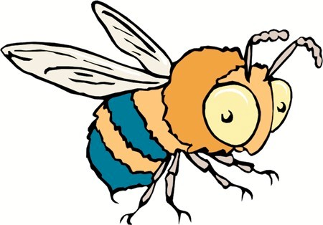w Spray the children with insectrepellent when theyplayoutsideifyouareinanareawithalot of insects.
w Exterminate insects in the house or center, but be extremely careful with the kind of insecticide or poison you use, when you use it, and how youuseit. Allofthesesubstancesaretoxicand can be dangerousto children if not used with extreme caution.
w Teach children to avoid insectsand to always tell you if they have been stung.
Snakes
There are at least four types of poisonous snakes in Texas: the coral, copperhead, rattlesnake, and water moc-­‐‑ casin.
w Always look out for snakes. Memorize what they look like and their habits.
w Teach the children never to go near a snake. Be suretoexplainthatnotallsnakesaredanger-­‐‑ ous. Some are very safe and helpful. However, until the children grow up and know the differ-­‐‑ ence, they must stay away from all snakes.
w Keep the yard free of rocks, boards, or other thingswheresnakesandinsectsmighthide.

Poisoning

Poison is anything you eat, breathe, or touch that can cause illness or death. Most poison deaths are caused by drugs, household chemical products, and fumes. Each year, over one million children swallow poisonous mate-­‐‑ rials. Seventy percent of all poison accidents involve chil-­‐‑ dren under the age of 5 . That leaves 30 percent, or 300,000 children, over the age of 5 who are poisoned each year.
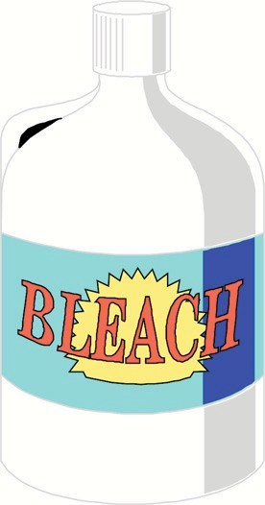Death by household poisoning is rising, and almost all of theseaccidentsarepreventable. Toprotectchildrenin your care, know which things around your home or cen-­‐‑ ter are poisonous and keep these out of children’s reach. In addition, have the number of your local poison control center as well as a poison antidote listing near the tele-­‐‑ phone. Always call a doctor or your poison control center if one of your children is poisoned. If possible, get some-­‐‑ one else to call while you administer first aid. Speed and the right aid are critical.

Household Chemical Products.
Mosthouseholdproductstodaymake life easier, but they are poten-­‐‑ tiallydangerouspoisons. Many products print caution state-­‐‑ ments on labels such as: “Poi-­‐‑ son,” “Caution,” “Harmful if Swallowed,” “For External Use Only” and “Keep Out Of The Reach of Children.” Many do not. You cannot always rely on the product label to give proper poison warnings. Products like detergents may be tasty to a toddler and deadly.
Household cleaners and polish-­‐‑ ers, such as lye, ammonia, bleach, cleansers, furniture polish,
soaps, detergents, and any grease cutting chemicals usu-­‐‑ allycontaincorrosives. Symptomsofcorrosivepoisoning may be nausea, burns on hands and mouth, burning throat, orstomachpains.
Treat corrosive poisoning by giving liquid to dilute the poison. If a child has swallowed a corrosive substance,
do not induce vomiting. Swallowing a corrosive causes burns. If you make the child vomit, the child is bringing up the same corrosive substance and can become burned even more.
If the child is 1 to 5 years old and alert enough to swal-­‐‑ low, give one to two cups of milk or water. Give as much asonequartifthechildisolder. Thiswillhelpdilutethe poison. Refer to a poison antidote chart for all poisoning.
Somepoisonous householdproductsdonotcontaincor-­‐‑ rosives. If a child swallows a substance which you know does not contain a corrosive, you should induce vomit-­‐‑ ing. Many similar products contain different substances so it is essential to check the label before deciding which treatment is appropriate.

Drugs

Alldrugswhichhavenotbeenprescribedforaspecific child are dangerous. Medicines which an adult can take safely can be deadly for a child. Children’s medicines and pills can be fatal if taken improperly.
The most common cause of accidental poisoning is an overdose of drugs. Young children especially like candy-­‐‑flavored vitamins and aspirin. These can be useful when taken as directed, but they also cancausedeathiftakenimproperly.
Symptomsofdrugoverdoseincludeincreased activity, sleepiness, shallow breathing, uncon-­‐‑ sciousness, or convulsions.
Never cause vomiting if a child is in a coma, hav-­‐‑ ingconvulsions, orunconscious. Otherwise, first aidfordrugoverdoseusuallycallsformaking the child vomit: Always check your poison anti-­‐‑ dotechart.

Cosmetics, Lotions, and Other External Preparations
Nail polish, perfume, cosmetics, hair dressings, and wood alcoholmay give no warning on the labelorsay what to do in case of accidental swallowing. These seem-­‐‑ ingly harmless items can be poisonous to a child. Symp-­‐‑ toms include an upset stomach and usually a tell-­‐‑tale

odor. These cosmetic and external substances can be cor-­‐‑ rosive. Check the ingredients on the label and then your poison chart.

Pesticides
Pesticides contain poisons that are deadly in very small quantities. Eating unwashedgarden vegetablesorbeing in or near a sprayed area can cause poisoning.
Arsenic, strychnine, DDT, and other poisons are found in manyweedkillersandpesticides. Symptomsinclude stomach and intestinal upset, dizziness, and uncon-­‐‑ sciousness. Read the label of pesticides for ingredients before administering first aid.

Petroleum Products
Gasoline and kerosene are examples of petroleum prod-­‐‑ ucts. Any odor of a petroleum product on a child’s breath or clothing is a danger signal. Symptoms include drowsi-­‐‑ ness, nausea, stomach pains, and unconsciousness.
Never cause vomiting if a child has swallowed a petro-­‐‑ leum product. Give the child milk or water. Petroleum productsalsocancauseskinburns.

Fume Poisoning

Gasspaceheatersandcarbonmonoxidefrom carsare possiblefumepoisoners. Anearlysymptomisahead-­‐‑ ache. Drowsiness, dizziness, and unconsciousness follow. Get fresh air to the child. Smash a window, if necessary. Call the doctor, police, or the poison control center. Give artificial respiration if the child has trouble breathing or has stopped breathing. Do not give the child food or drink, and keep the child as quiet and warm as possible.

Plant Poisoning
Many poisonous plants are common to Texas. Some are houseplants and some outdoor plants. Some cause seri-­‐‑ ous illness, and some cause death. Narcissus, larkspur, wisteria, iris, azalea, poinsettia, and dieffenbachia all have poisonous parts. More than 700 kinds of plants can cause serious illness and death because they are poison-­‐‑ ous. Since there are so many dangerousplants, consult
your local poison control center about all plants you have indoors and outdoors. You also can ask them for a full listing of harmful plants. Once you identify them, re-­‐‑ move the plants from any area where the children could reach them. Teach children never to eat any part of a plantwhichisnotcommonlyusedasfood. Checkyour yard and garden regularly to make sure these plants have notstartedgrowingagain.
This is a list of some of the more common poisonous plants:

Azalea
Allpartsare poisonous. Symptomsinclude nausea, vom-­‐‑ iting, and difficulty in breathing. Ingestion may be fatal

Buttercup
All parts are poisonous. Symptoms include salivation, stomachandintestinalirritation, vomiting, diarrhea, and, sometimes, convulsions.

Caladium
Allpartsarepoisonous. Symptomsincludeirritation, swelling, and intense pain of the mouth, lips, cheeks, and throat. Ingestionofcaladiumsmayblockbreathingor swallowing.

Castor Bean
Thisbean seed is poisonous. Symptomsinclude nausea, vomiting, diarrhea, intestinal colic, thirst, and convul-­‐‑ sions. One or two bean seeds will be a fatal dose.

Delphinium
All parts are poisonous. Symptoms include tingling of mouth, nausea, vomiting, diarrhea, lowbloodpressure, weak pulse, and convulsions. May be fatal.

Dieffenbachia
AII parts are poisonous. Symptoms include irritation, swelling, and intense pain in the mouth, lips, throat, and cheeks. May block breathing or swallowing.

Daffodil
Bulb is poisonous. Symptoms include vomiting, diarrhea, trembling, andconvulsions. Maybefatal.

Elephant Ear
All parts are poisonous. Symptoms include irritation,

swelling, and intense pain in the mouth, lips, throat, and cheeks. May block breathing or swallowing.

English Ivy
Allpartsare poisonous. Symptomsinclude diarrhea, ex-­‐‑ citement, labored breathing, and coma.

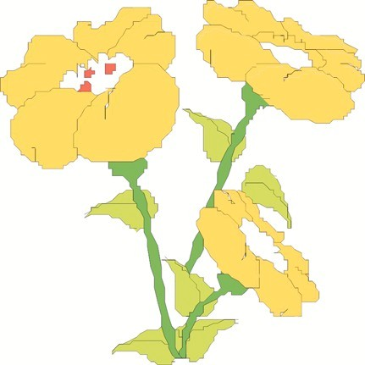Foxglove
All parts are poisonous. Symp-­‐‑ tomsincludevomiting, dan-­‐‑ gerously irregular breathing andpulse, andmentalcontu-­‐‑ sion. May be fatal.

Holly
Berries are poisonous. Symptoms include nausea, vomiting, diarrhea, and stupor.

Hyacinth
Bulbispoisonous. Symptomsincludenausea, vomiting, and diarrhea.

Hydrangea
All parts contain cyanide producing substances and are poisonous. Symptoms include vomiting, dizzi-­‐‑ ness, headache, diarrhea, fast heart rate, rapid breathing, and convulsions.

Iris
Bulbispoisonous. Symptomsincludenausea, vomiting, and diarrhea. Toxic effects on the liver and pancreas.

Jimson Weed (thorn apple)
Allpartsarepoisonous. Symptomsincludeabnormal thirst, distorted vision, and coma.

Larkspur
Allpartsarepoisonous. Symptomsincludedigestiveup-­‐‑ set and nervous excitement.

Laurels
Allpartsarepoisonous. Symptomsincludeexcitement, high followed by low blood pressure, rapid heart rate, and delirium. May be fatal.

Mistletoe
All parts are poisonous. Symptoms include vomiting,
diarrhea, slowed pulse, and circulatory collapse. May be fatal.

Narcissus
Bulb is poisonous. Symptoms include vomiting, diarrhea, trembling, andconvulsions. Maybefatal.

Oleander
Allpartsarepoisonous. Symptoms include nausea, vomiting, depres-­‐‑ sions, slowed and irregular pulse, dilated pupils, steady diarrhea, and paralysis. May be fatal.

Philodendron
All parts are poisonous. Symptoms includeirritation, swelling, andintense pain in the mouth, lips, throat, and
cheeks. May block breathing or swallowing.

Poinsettia
Allpartsarepoisonous. Symptomsinclude burning in the mouth and throat, vomiting, diarrhea, and intestinal irritation.

Poison Ivy,Oak,and Sumac
All parts are poisonous. Symptoms include itching, ooz-­‐‑ ing sores, swelling of throat and mouth, weakness, fever, and reduced urine output.

Rhododendron
Allpartsare poisonous. Symptomsinclude nausea, vom-­‐‑ iting, and difficulty in breathing. May be fatal.

Rhubarb
Leaf only is poisonous. Symptoms include abdominal cramps, vomiting, weakness, andmuscularcramps. May be fatal.

Wisteria
Seedsandpodsarepoisonous. Symptomsincludemild toseveredigestiveupset.

Yews
Berries and foliage are poisonous. Foliage is more toxic than berries. Symptoms include nausea and vomiting. Canbefatalwithoutsymptoms.

Food Poisoning
Proper storage and preparation of food is extremely im-­‐‑ portantinpreventingthegrowthofharmfulbacteria which can cause food poisoning. Some foods can spoil within hours if not stored properly. Foods containing dairy products provide the best breeding places for bac-­‐‑ teria. Milk, baby formula, salad dressing, cream sauces, milk gravies, cream-­‐‑filled pies, and pastries are all items that need to be refrigerated. Sausages, poultry, ground beef, fish, and rapid cured hams also willspoilquickly.

Purchasing Food
Check expiration dateon allrefrigerated itemsbefore purchasing. Thesefooditemsarerequiredbylawtobe dated. Often a store will sale price these items when they reach expiration date. Do not buy these items even though they may be perfectly good. Because you are buy-­‐‑ ing this food for children in your care, be extra careful.
Testthetopsofscrewjarsfortightness. Theymayhave loosened accidentally or another shopper may have been curious or destructive. This is especially important with baby food jars.
Neverbuyacanthatisbulging. Thisisaclearsignthat the food has gone bad. Do not purchase dented cans be-­‐‑ cause there is a possibility the food is spoiled.

Food Storage
Keep food either very hot or very cold. Bacteria will not grow as easily in cooking food, and refrigeration slows down bacterial growth. Cover and refrigerate leftovers immediately.
Refrigeratealluncookedmeatsanddairyproducts. These will spoil eventually even if refrigerated. Freeze meat if it is not going to be used in two days. Throw away dairy products if they are not used by the expira-­‐‑ tion date or if they smell spoiled before that date.
Never thaw and then refreeze food. It can be thawed, cooked, and then refrozen.
Store unopened baby food. jars in a dry, moderately cool place. Cover and refrigerate any leftovers immediately.
Get rid of any moldy foods. Throw away any food you are not sure about.
Always wash baby bottles immediately after using them. Formula and milk left in a bottle can cause bacteria to grow.

Preparing Food
When cooking, always use food that you know is good. Milk, eggs, meats, and other foods should always be in good condition.
Pork alwaysshould be cooked thoroughly. Keep allcook-­‐‑ ingutensilsingood, cleancondition.
Washallfreshvegetablesandfruits.

Lead Poisoning

The main source of lead poisoning in a home or center is dried, peeling paint on walls, woodwork, repainted fur-­‐‑ niture, ortoys. Childrenoftensuckandchewonfurni-­‐‑ ture. They pick and pull off peeling paint and then put it into their mouths. You may not know which items in your house have been painted with lead base paint. Even if you paint with lead-­‐‑free paint, there is the danger that old layers of paint underneath may have high lead con-­‐‑ tent.
w Takenochances. Checkregularlyforpeeling paint on furniture, toys, window and door sills, porch steps, bars or iron gates, and interior and exterior walls (Note: Outdoor paints may have a highleadcontent.)
w Teach children neverto bite on furniture, toys, windowsills, andotherpaintedsurfaces.
w Remove all toys, furniture, and otherobjects wherepaintispeeling.
w When repainting objects, toys, or furniture, always remove all layers of paint and then use a lead-­‐‑free paint.
w When choosing wooden toys, buy unpainted toys or toys with labels, indicating they have beenpaintedwithlead-­‐‑freepaint.

Poison Prevention
w Inspect your home or center every, day to be sure none of the poisonous items mentioned earlier are left where children can get to them. It is easy to use a cleaning fluid or take a medicine in the evening and forget to.put it away.
w Keep all household chemicals in a locked cabi-­‐‑ net and out of reach of young children.
w Keep garage doors, tool sheds, and other areas where paint, gasoline, turpentine, insecticide, garden chemicals, or other such things are stored locked at all times
w Throw away empty containers in a safe con-­‐‑ tainer outside the home or center. Sometimes children go through trash or garbage cans and play with empty containers which might have had poisonous substances. Put empty poison containers in the garbage can just before trash pick up time, not the night before.
Better yet, hand the empty container to the trash collector.
w Neverputpotentialpoisonsintofoodcontainers such as a glass, bowl, jar, soft drink, or milk bottle. Adults as well as children have died from drinking or eating poisonous items stored in food containers.
w Keepdrugs, medicines, andcosmeticsina lockedareaawayfromwherechildrenplay.
w Sometimes you will have to give children medi-­‐‑ cine, but do not do so unless you have written permission from the parents. Never give the child medicine prescribed for another person. Never give more than the prescribed dosage and remember to throw away old or leftover medi-­‐‑ cine. Throw away medications the same way you would a poison-­‐‑very carefully.
w Teach children neverto putanything in their mouth that is not food or drink.
w Rememberthatalldrugsandhouseholdchemi-­‐‑ cals must be kept out of reach of children.

Water Safety

Watercanbefun, butitisalsodangerous. Swimming pools are obviously a danger to young children; and adults usually are aware of that danger. However, small wadingpoolsandbathtubsalsocanbedangerous. No child should be left alone in water—whether it is the backyard wading pool or the bathtub. It only takes a few secondstofallanddrown. Anadultalwaysshouldbe present and in easy reach of the child.

Wading Pools
Wading pool play should be watched closely even with olderchildren. Whenchildrenareplayingtogether, they often start pushing and shoving each other. They do not understandthiscouldbedangerous. Withoutintending tobemeanorhurtful, theymayholdachild’sheadun-­‐‑ der water.
w Do not allow heavy or sharp objects in the pool area. Children enjoy throwing things to make a splash in the water. Their aim is not always ac-­‐‑ curate, and they may hit another child.
w Drainandcleanwadingpools everyday With larger pools, be sure the filter system is working and the water is clean and clear.

Swimming Pools
w Do not allow any electrical equipment such as a radio insidethefenced areaunlessitispartof standard pool operating equipment. Make sure children who cannot swim wear life jackets and stay in shallow water.
w Use the “buddy system” for all older children, eventhoughsupervisedbyanadult.
w Checkwithyour Texas Departmentof Human Services licensing representative for current swimming pool standards.

Swimming Lessons
All children should take swimming lessons as soon as possible. Although 6 and 7 yearolds learn more quickly, children asyoung as 6 monthscan betaughtto swim well enough to keep from drowning. Very young chil-­‐‑ drenarenotafraidofthewaterorawareofthedanger. Because of this, all preschoolers who are around a pool should be taught how to swim for their own protection.
Red Cross swimming lessons by certified water safety instructors are available in most cities during the sum-­‐‑ mer. Theselessonsareusuallyfree, orthereisonlya small pool charge. Each water safety instructor must teach at least one Red Cross swimming course free of

charge each year to maintain certification. The local Red

Swimming pools should have a high fence around them and a gate that can be locked. Always lock the gate, even ifyou plan to return in justafew minutes. Manytragic accidents happen in just a few minutes.
w Supervise all swimming pool activities. Test poolsdailyforproperchemicalbalance.
w Keep all pool equipment clean and in good working condition.
w Keep life saving equipment such as a life buoy or long pole within easy reach of the supervis-­‐‑ ing adult.
Cross office usually keeps a list of instructors who want
to teach a course. Sometimes, you can find a person who is eager to teach a course in order to keep the certifica-­‐‑ tion.
Olderchildrenwilloftensaytheyknowhowtoswim whentheyreallydon’t. Donottrustthechild’sword. Always have a child swim for you and judge the child’s ability yourself.

Automobile Injury Prevention

There are a number of very dangerous situations in which children are exposed to possible injury from auto-­‐‑ mobiles. Someoftheseincluderidinginacarwithout seatbelts, playinginabandonedcars, andplayingina driveway.
Rules
Youmustalwayshavewrittenpermissionbeforetaking
w Useonlyinfantcarriersdesignedformotoring and only seats which have the manufacturer’s Certification of Compliance with the require-­‐‑ mentsof Federal Motor Vehicle Standard No.
213. Do not take a child anywhere in an unsafe carrier even if the parents provide it.
w Pulloverandstopifchildrenmisbehave.

Safety Precautions

childreninanautomobile. Ifyoutakechildrenanywhere,

be very firm about automobile rules.
w Lock all doors and fasten seat belts before the carisstarted. Ifthebeltdoesnotgooverhips, use a car seat.
w Do not allow any part of the body to extend through a window.
w Do not touch door and window handles unless permission is given.
w Stay seated and belted until the car is stopped.
w Never leave the keys in the car when you are not behind the wheel. Always engage the emer-­‐‑ gency brake before you leave the car.
w Alwayslockparkedcars.
w Never allow children to play in a driveway.
w Neverleavechildrenaloneinacar. Children have been known to release brakes or
change gears and let cars coast or
burnthemselveswiththeciga-­‐‑ rette lighter Children also have died of heat prostration in locked cars with the windows up.

Fires, Burns, and Electric Shock

Stoves, heaters, radiators, fireplaces, electriccookingap-­‐‑ pliances, irons, electrical outlets and cords, matches, and cigarette lighters are potential fire hazards. You never can be too careful about any of these things.

Preventing Fires and Burns
w Never leave children alone in a house. In min-­‐‑
w Check for matches or cigarette lighters left lying around each morning before the children arrive. Remove and store matches and lighters in a safe place.
w Haveaworkingfireextinguisheravailableand know how to use it.

Preventing Electric Shock

utes, a child can start a fire or be burned.

w Never allow children in the kitchen or any area wheresomeoneiscooking. Ittakeslessthana second for a child to pull a cord on a slow cooker, toaster, or coffee pot, or the handle of a container of hot liquid. There is also the possi-­‐‑ bility that the child could be splashed with hot foodswhilefoodsarecooking.
w Put guards around heaters, radiators; furnaces, and any other object that is a fire hazard.
w Cover all 220 volt air conditioner outlets with a guard.
w Usechild-­‐‑proofcoversorheavyelectricaltape on unused electric outlets to keep children from poking their fingers, toys, or other objects into the outlets.
w Avoid using extension cords. Place electrical equipment close to outlets and roll up any extra cord.
w Push the television set against a wall so the back of the set is not easy to get to.
w Warn children not to tug or chew on electric cords.

Planning for Emergencies

All schools and homes should have emergency plans. Emergencies do happen, and well thought out and prac-­‐‑ ticed emergency procedures can save lives.
Fire

Fire Plan
Plantwoexitsfromeveryroom. Ifoneexitisthrougha window, check to be sure the window will open. Draw a plan of your center with the exits clearly marked and at-­‐‑ tach a copy of the plan to the wall in every room. Exits mustbeuncluttered. Knowthelocationofthenearest fire alarm box or phone outside your center. Tell the par-­‐‑ ents about your fire escape plan and encourage them to make their own home plans. Tell them it is important for every family to have an emergency meeting place out-­‐‑ side the home where they can meet safely if they have to leave the home because of a fire.

Fire Practice
Have fire drills at least once every three months at differ-­‐‑ ent times of the day. Then, if there is a fire, you and the children will know exactly what to do.
- Assign one person to ring a bell or blow a whistle for emergency procedures.
- The class immediately should follow the teacher to the doorandoutofthebuildingtoadesignatedspotabout 200 feetfromthebuilding. Thiscouldbeatreemarked with something like a red ribbon.
- Place babies in one crib and roll to the marked place.
- Upon arrival at the marked spot, immediately check roll to make sure everyone is there. This may be done by a head count.
- Assign one person to blow the whistle as a signal to return.
- Go back to the center by the same route you left it.
Fire When a fire starts, close doors between you and the fire and leave by the safest exit.
- Take the children out. Don’t stop to get anything.
- Whenyougettothedesignatedspot, doaheadcount
to be sure all the children are with you.
- One person should stay with the children. Call the fire department.
Severe WeatherConditions
Texas is subject to severe weather conditions, so be pre-­‐‑ pared for these emergencies. Have a battery-­‐‑operated radioinyourcenter. Youcanpickupwarningsifyou suspect bad weather is coming, and you can continue to listen for bulletins if electricity is interrupted because of the weather.
In a severe storm, take the children to the safest place in your center. It may be a hallway with inside walls, away from windows, away from the television set, and away from water pipes.
If a tornado warning is issued, open the windows on the side of the building away from the direction the storm is coming. Role play or practice these procedures with the children.

First Aid
Every home and center should have a first aid kit.
Many different types of first-­‐‑aid kits are available. It is notnecessarytopurchaseanexpensivecontainer. What is inside is more important.
Kits can be brightly painted lunch pails, shoe boxes, plas-­‐‑ tic buckets, or mesh sacks. If possible, have two kits, one for center or home use and one to take on field trips.
Keepkitsinacupboardorclosetonashelfhigherthan any of those used by the children. Always keep the door closed.
The kit should contain poison antidotes and enough ma-­‐‑ terials and medicines to take care of minor scrapes, cuts, and scratches. A kitshould contain the following:
Small bottle or bar of antiseptic soap Sterilegauzesquares(3"ʺx 3"ʺ, 2"ʺx 2"ʺ) Baking soda (for bites and stings) Bandages (1"ʺ rolls, 2"ʺ rolls) Adhesive bandages (all sizes)

Wooden applicators and toothpicks Adhesive tape (several sizes) Absorbent cotton (rolls and balls) Alcohol (70%)
Tweezers
Scissors (small, good quality) Triangular bandages to use for slings (30"ʺ or 40"ʺ) Hand basin
Splints (cardboard) Basin for vomiting Safety pins
Two or three covered glass jars large enough for tongue depressors and long applicators
Syrup ofipecac (poison antidote, willinduce vomiting) Disposable tissues
Medicine droppers Paper towels Paper cups Tongue depressors
Cotton-­‐‑tipped wooden applicators Burn ointment Mineraloil(poisonantidote) Ice bag or plastic bag for ice
Moist gauze pads moistened with an antiseptic agent
w Replacefirst-­‐‑aid itemsandmedicinesasneeded and keep them in good condition.
w Purchaseitemssuchasadhesivebandages, tape, andointmentswhenhalfofeachitemhasbeen used. Items such as basins and tweezers should be kept clean and in good condition.
w Before using, check any medications kept in the first-­‐‑aid kit for the expiration date. Replace any medications that are close to the expiration date. Expired medication should be thrown away.
Every center and home should have a first aid chart and apoisonantidotechart. Whenachildisinjuredorpoi-­‐‑ soned, it is frightening for both the child and the caregiver. Postthefirst-­‐‑aidchart, thepoisonantidote chart, and emergency numbers on the wall near the tele-­‐‑ phone and, if possible, near the first-­‐‑aid kit. Any serious problem will require a telephone call to an ambulance, physician, poisoncontrolcenter, orparents. Placecharts, first-­‐‑aid kit, emergency numbers, and the telephone to-­‐‑ gether. This will speed up emergency care and may re-­‐‑ duce panic.
First-­‐‑aid charts and poison antidote charts are available. Achartentitled“First Aid” isavailablefromthe Texas Department of Human Services. Get this chart from your local DHR office, or from your local public health depart-­‐‑ ment.

Post emergency numbers. Emergency numbers should include:
w the local poison control center or a poison con-­‐‑ trol hot line number listed in your local tele-­‐‑ phone directory,
w the closest hospital emergency room,
w the closest ambulance service,
w thenearestfiredepartment,
w a neighbor you could call in an emergency, and
w an emergency number for each child in your care. Post these numbers by the telephone in chart form or list in a personal address and tele-­‐‑ phone book. All children in your care will have emergency numbers and additional information

in theirrecord file. Thepurposeisto haveim-­‐‑ mediate access to a telephone number in case of a critical situation.
If you have an emergency and do not have ready access to appropriate numbers, call the telephone operator. De-­‐‑ clare an emergency. Tell the operator your problem and whathelpyouneed. Usethisprocedureasalastresort andonlyinatrueemergency.
No matter how careful you are, there is no guarantee that
anemergencysituationwillnothappen. Themostim-­‐‑ portant points to remember are to plan ahead of time what to do in an emergency, practice or rehearse with the children, keepcalm, andactquicklytopreventfurther damage. It is to your advantage to:
w have first-­‐‑aid materials on hand, know first aid, and
w post a list of emergency telephone numbers near the phone.

